INDEX

DSA

1: Array-Based Programs

1. Insert an element at a given position.
2. Delete an element from a given position.
3. Search for an element using linear search.
4. Search for an element using binary search.
5. Reverse an array (in-place).
6. Merge two arrays.
7. Remove duplicate elements from an array.
8. Implement matrix multiplication.

2: Singly Linked List Programs

9. Create a singly linked list and count the number of nodes.
10. Insert a node at beginning, end, and specific position.
11. Reverse a singly linked list.
12. Merge two singly linked lists.

3: Tree Programs

13. Binary Tree Traversal.

1. Insert an element at a given position.

#include <iostream>
using namespace std;

void insert(int item, int index, int *array, int size)
{
int i = size - 2;
// Right shifting
while (i >= index)
{
array[i + 1] = array[i];
i--;
}
array[index] = item;
}
int main()
{
int array[] = {1, 2, 3, 4, 5};
insert(2, 3, array, 5);
for (int i : array)
{
cout << i << " , ";
}
return 0;
}

OUTPUT :
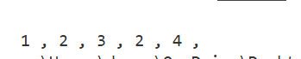

2. Delete an element from a given position.

#include <iostream>
using namespace std;
void remove(int index, int *array, int size)
{
// Left Shifting
for (int i = index; i < size; i++)
{
array[i] = array[i + 1];
}
array[size - 1] = 0;
}

int main()
{
int array[] = {1, 2, 3, 4, 5, 6, 7};
remove(3, array, 7);
for (int i : array)
{
cout << i << " , ";
}

return 0;
}

OUTPUT :

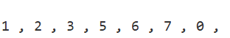

3. Search for an element using linear search.

#include <iostream>
using namespace std;
int search(int item, int *array, int size)
{
// Left Shifting
for (int i = 0; i < size; i++)
{
if (array[i] == item)
return i;
}
return -1;
}

int main()
{
int array[] = {1, 2, 3, 4, 5, 6, 7};
cout << "Found 7 at : " << search(7, array, 7) << "\n";
cout << "Found 8 at : " << search(8, array, 7);
return 0;
}

OUTPUT :

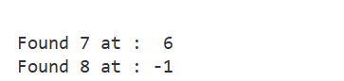

4. Search for an element using binary search.
#include <iostream>
using namespace std;
int search(int item, int low, int high, int *array, int size)
{
while (low <= high)
{
int mid = high - (high - low) / 2; // to avoid overflow
int current = array[mid];
if (item < current)
return search(item, low, mid - 1, array, size);
else if (item > current)
return search(item, mid + 1, high, array, size);
else
return mid;
}
return -1;
}
int main()
{
int array[] = {1, 2, 3, 4, 5, 6, 7};
cout << "Found 2 at : " << search(2, 0, 6, array, 7) << "\n";
cout << "Found 6 at : " << search(6, 0, 6, array, 7) << "\n";
cout << "Found 8 at : " << search(8, 0, 6, array, 7);
return 0;
}

OUTPUT :
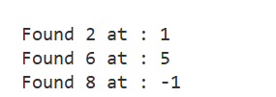

5. Reverse an array (in-place).
#include <iostream>
using namespace std;
void reverse(int *array, int size)
{
int low = 0;
int high = size - 1;
while (low <= high)
{
swap(array[low], array[high]);
low++;
high--;
}
}
int main()
{
int array[] = {1, 2, 3, 4, 5, 6, 7};
reverse(array, 7);
for (int i : array)
{
cout << i << " , ";
}
return 0;
}

OUTPUT :
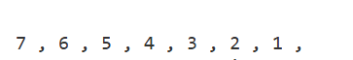

6. Merge two arrays.
#include <iostream>
using namespace std;
int *merge(int *array1, int size1, int *array2, int size2)
{
int total_size = size1 + size2;
int *result = new int[total_size];
int i = 0;
for (; i < size1; i++)
{
result[i] = array1[i];
}
for (; i < total_size; i++)
{
result[i] = array2[i - size1];
}
return result;
}
int main()
{
int array1[] = {1, 2, 3, 4, 5, 6, 7};
int array2[] = {1, 22, 13, 4};
int *array3 = merge(array1, 7, array2, 4);
for (int i = 0; i < 11; i++)
{
cout << i[array3] << " , ";
}
return 0;
}

OUTPUT :

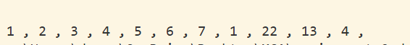

7. Remove duplicate elements from an array.
#include <iostream>
using namespace std;
void remove_duplicate(int *array, int size)
{
int *result = new int[size];
int k = 0;
for (int i = 0; i < size; i++)
{ bool found = false; int current = array[i];
for (int j = k; j >= 0; j--)
{if (current == result[j])
{found = true; break ;}
}
if (!found) {result[k] = current; k++;}
for (int i = 0; i < k; i++)
{
cout << result[i] << " , ";
}
}
int main()
{
int array[] = {1, 2, 1, 4, 4, 6, 7, 1, 0, 7, 9, 6};
for (int i : array)
{
cout << i << " , ";
}
cout << endl;
remove_duplicate(array, 12);
return 0;
}

OUTPUT :
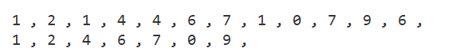

8. Implement matrix multiplication.
#include <iostream>
using namespace std;
void matix_multiplication(int m1[][4], int m2[][2], int r1, int c1, int r2, int c2)
{
if (c1 != r2)
{
cout << "row in m1 must be equal to col in m2";
return;
}
int **result = new int *[r1];
for (int i = 0; i < r1; i++)
{
result[i] = new int[c2];
}
for (int i = 0; i < r1; i++)
{
for (int j = 0; j < c2; j++)
{
int sum = 0;
for (int k = 0; k < c1; k++)
{
sum += m1[i][k] * m2[k][j];
}
result[i][j] = sum;
}
}
int r = r1;
int c = c2;
cout << "\n";
for (int i = 0; i < r; i++)
{
for (int j = 0; j < c; j++)
{
cout << result[i][j] << ",";
}
cout << "\n";
}
cout << "\n";
}

int main()
{
int m1[2][4] = {{1, 2, 3, 4}, {5, 6, 7, 8}};
int m2[4][2] = {{1, 2}, {3, 4}, {5, 6}, {7, 8}};
for (int i = 0; i < 2; i++)
{
for (int j = 0; j < 4; j++)
{cout << m1[i][j] << ",";
}cout << "\n";
}
cout << "\n";
for (int i = 0; i < 4; i++)
{
for (int j = 0; j < 2; j++)
{cout << m2[i][j] << ",";
}cout << "\n";
}
matix_multiplication(m1, m2, 2, 4, 4, 2);
return 0;
}

OUTPUT :
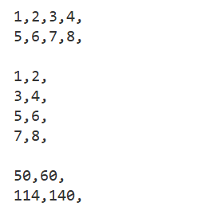

9. Create a singly linked list and count the number of nodes.
#include <iostream>
using namespace std;

struct Node
{
int data;
Node *node;
};

int count(Node *head)
{
int number_of_nodes = 0;
while (head)
{
head = head->node;
number_of_nodes++;
}
return number_of_nodes;
}
int main()
{
Node *n3 = new Node{3, NULL};
Node *n2 = new Node{3, n3};
Node *n1 = new Node{3, n2};

cout << "size : " << count(n1);
return 0;
}

OUTPUT :
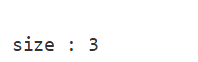

10. Insert a node at beginning, end, and specific position.
#include <iostream>
using namespace std;
struct Node
{
int data;
Node *next;
};
Node *head;
void print()
{
Node *temp = head;
while (temp)
{
cout << temp->data << " -->";
temp = temp->next;
}
}
void insert_beginning(int value)
{
Node *new_node = new Node{value, NULL};
new_node->next = head;
head = new_node;
}
void insert_end(int value)
{
Node *new_node = new Node{value, NULL};
if (!head)
{
head = new_node;
return;
}
Node *temp = head;
while (temp->next)
{
temp = temp->next;
}
temp->next = new_node;
}
void insert_location(int value, int index)
{
if (!head || index == 0)
{
insert_beginning(value);
return;
}

Node *new_node = new Node{value, NULL};
Node *temp = head;
for (int i = 0; i < index - 1 && temp->next; i++)
{
temp = temp->next;
}
new_node->next = temp->next;
temp->next = new_node;
}
int main()
{
insert_beginning(2);
insert_beginning(1);
insert_end(3);
insert_end(4);
insert_location(-1, 0);
insert_location(5, 2);
print();
return 0;
}

OUTPUT :
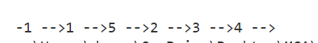

11. Reverse a singly linked list.

#include <iostream>
using namespace std;
struct Node
{
int data;
Node *next;
};
Node *head;

void print()
{
Node *temp = head;
while (temp)
{
cout << temp->data << " -->";
temp = temp->next;
}
cout << "\n";
}

void reverse()
{
Node *prev = NULL, *next = NULL, *cur = head;
while (cur)
{
next = cur->next;
cur->next = prev;
prev = cur;
cur = next;
}
head = prev;
}

int main()
{

Node *n3 = new Node{3, NULL};
Node *n2 = new Node{2, n3};
head = new Node{1, n2};
print();
reverse();
print();
return 0;
}

OUTPUT :
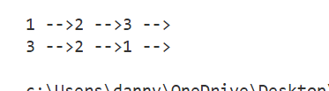

12. Merge two singly linked lists.
#include <iostream>
using namespace std;
#define N(x, y) \
new Node { x, y }
struct Node
{
int data;
Node *next;
};

void print(Node *head)
{
Node *temp = head;
while (temp)
{
cout << temp->data << " -->";
temp = temp->next;
}
cout << "\n";
}
Node *merge(Node *l1, Node *l2)
{
if (!l1)
return l2;
Node *temp = l1;
while (temp->next)
{
temp = temp->next;
}
temp->next = l2;
return l1;
}

int main()
{
Node *l1, *l2;
l1 = N(1, N(2, N(3, NULL)));
l2 = N(4, N(5, N(6, NULL)));
print(l1);
print(l2);
merge(l1, l2);
print(l1);
return 0;
}

OUTPUT :

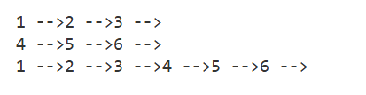

13. Binary Tree Traversal.
#include <iostream>
#include <stack>
using namespace std;
struct Node
{
int data;
Node *left = NULL, *right = NULL;
};
void printNode(Node *node, int indentation)
{
if (!node)
return;

string indent(indentation, ' ');
cout << indent << "->" << node->data << "\n";

printNode(node->left, indentation + 2);
printNode(node->right, indentation + 2);
}
void printTree(Node *root)
{
cout << "Tree\n";
printNode(root, 0);
}

void print(Node *node)
{
cout << "[" << node->data << "]";
}
void preOrder(Node *root)
{
if (root == NULL)
return;
stack<Node *> s;
Node *cur = root;

while (cur)
{
print(cur);
if (cur->right)
s.push(cur->right);
if (cur->left)
cur = cur->left;
else
{
cur = s.top();
s.pop();
}
}
}

int main()
{
Node *n5 = new Node{5};
Node *n4 = new Node{4};
Node *n3 = new Node{3};
Node *n2 = new Node{2};
Node *n1 = new Node{1};
Node *root = new Node{0};

root->left = n1;
root->right = n2;
n1->left = n3;
n1->right = n4;
n2->left = n5;

printTree(root);
cout << "Preorder Traversal : ";
preOrder(root);
return 0;
}

OUTPUT :

